Assignment 4

create table Borrower
-> (Roll_no int primary key, Name varchar(20), DateofIssue date, NameofBook varchar(20), Status char);

Create table Fine( Roll_no int, Date date, Amt float, foreign key(Roll_no) references Borrower(Roll_no));

INSERT INTO Borrower VALUES
(1, 'Ashok', '2025-07-14', 'Ikigai', 'I'),
(2, 'Pranav', '2025-06-01', 'Atomic Habits', 'I'),
(3, 'Aditya', '2025-07-24', 'Robinson Crusoe', 'I'),
(4, 'Prathamesh', '2025-05-29', 'The Hell Paradise', 'R');

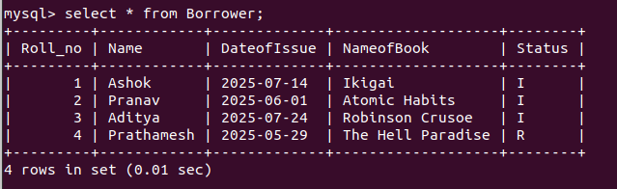

Creating procedure